LAB EXPERIMENTS

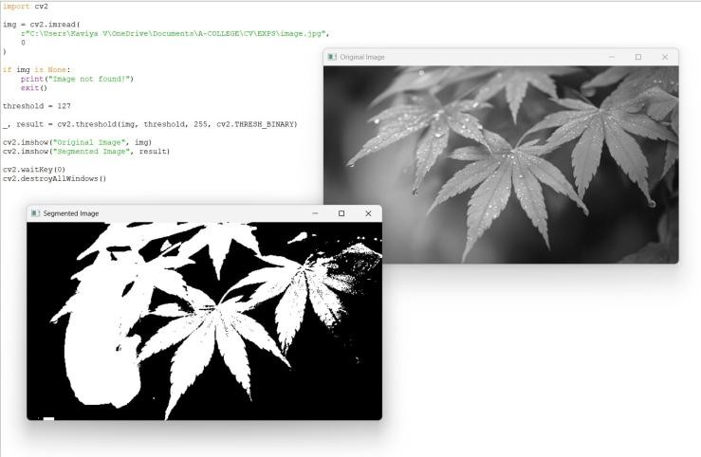
- Implement a Segmentation algorithm using Open CV to segment the given input image based on the given threshold values.
- Write a Python function to create a white image size entered by the user and then create 4 boxes of Black, Blue, Green and Red respectively on each corner of the image. The size of the colored boxes should be 1/10th the size of the image. (HINT: the arrays of ones and zeros can be in more than 2 dimensions).
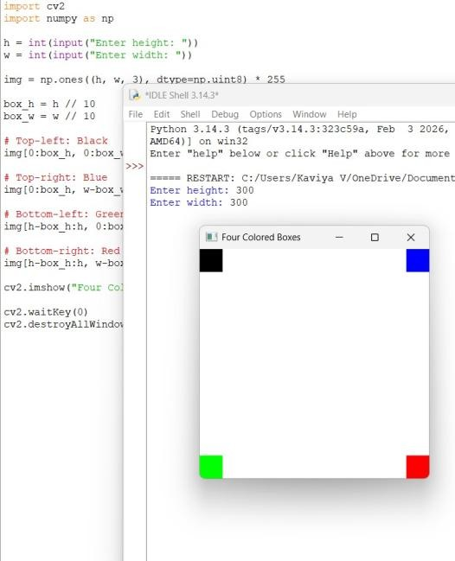

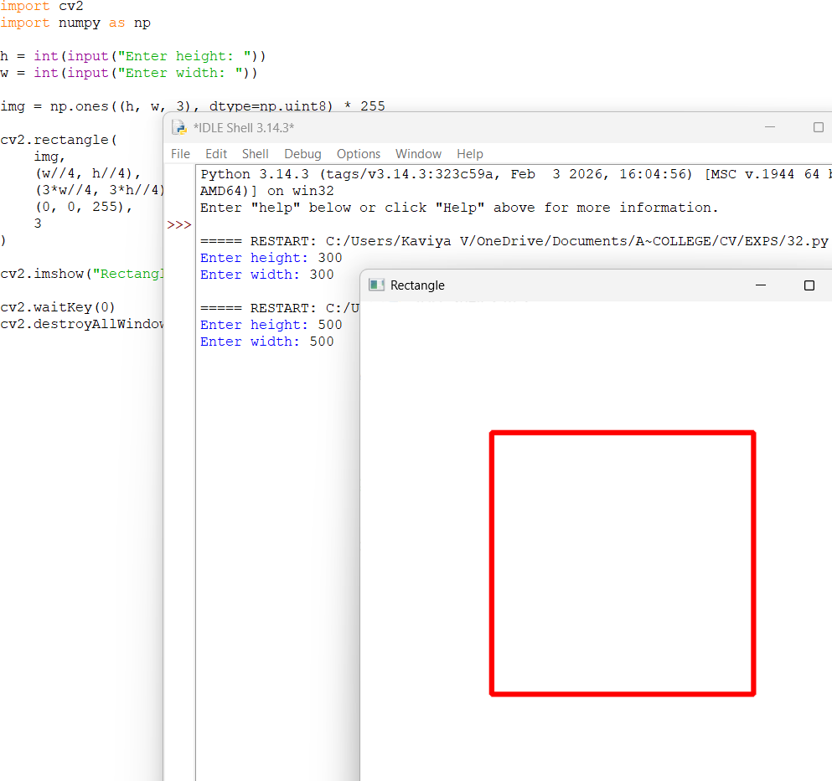
- Write a Python function to create a white image size entered by the user and then create a shape of Rectangle using Open CV.
- Write a Python function to create a white image size entered by the user and then create a shape of Circle using Open CV.
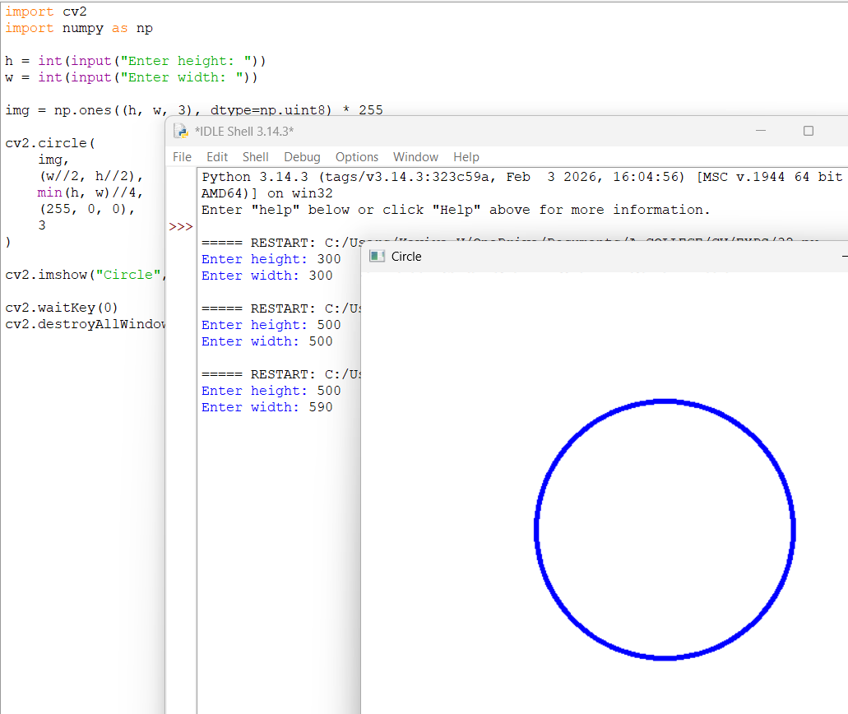

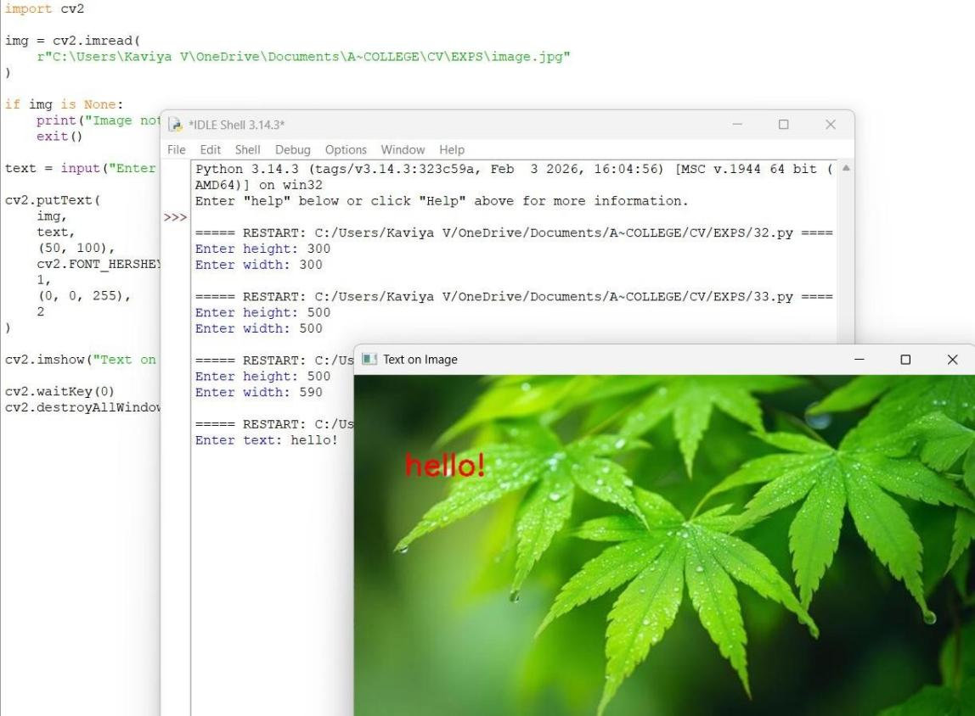
- Write a Python function to create a text string entered by the user that must be appeared on the given image using Open CV.
- Write a Python function to subtract the background of the given input image based on color levels using Open CV.
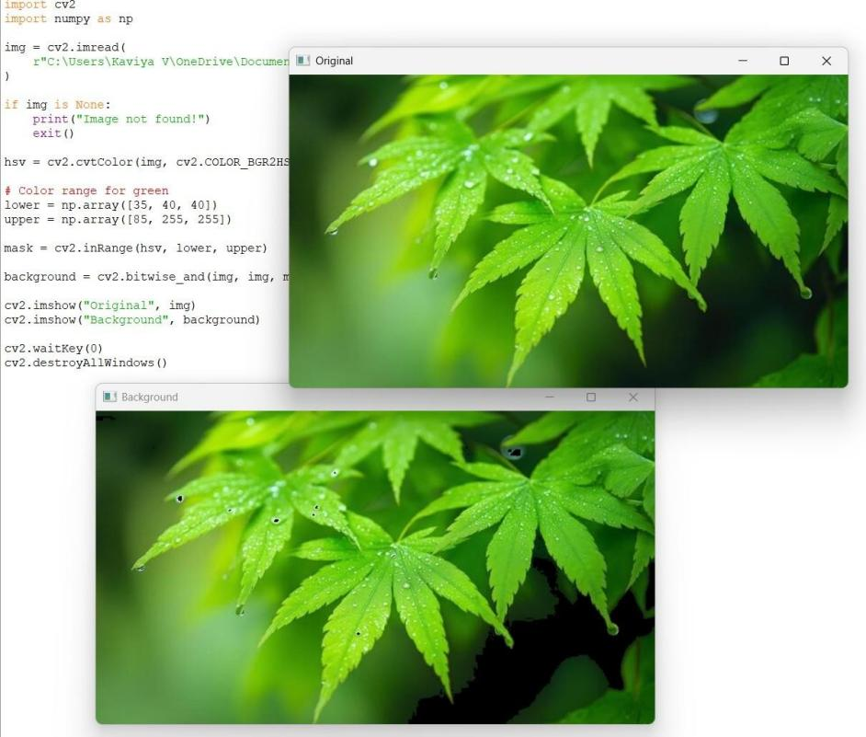

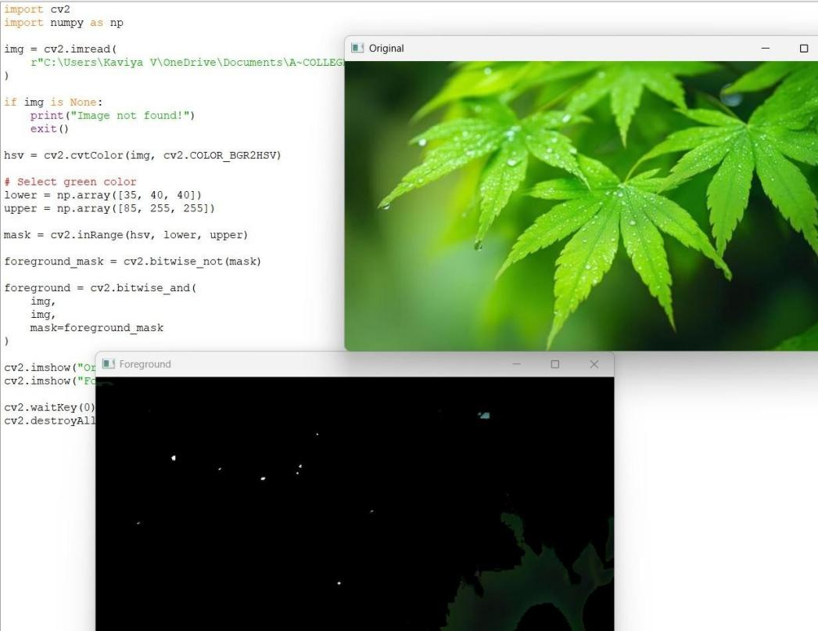
- Write a Python function to subtract the foreground of the given input image based on color levels using Open CV.
- Write a Python function to Count the number of faces for the given input image using Open CV.
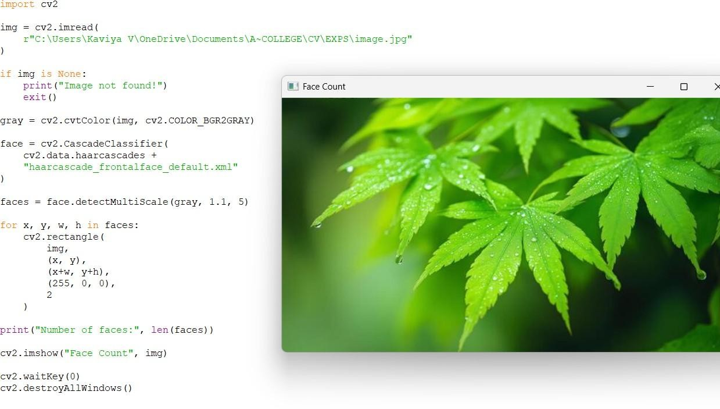

- Write a Python function to play the given video in reverse mode in slow motion.
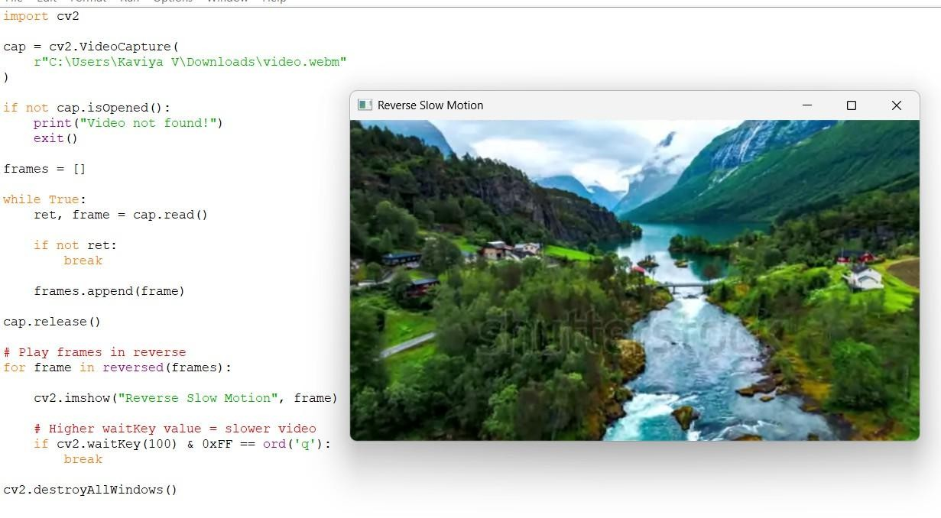
- Write a Python function to extract the text from videos.
